Turning Surplus Into Love: North Carolina’s Chinese Community Donates PPEs to Medical Personnel
By Emily Xu
North Carolina's congressional candidate Deborah presents medical supplies to the hospital along with the Chinese community.
North Carolina’s Chinese community has finished supporting Wuhan and is now combating the spread of the COVID-19 in the local area. Recently, the three local medical systems UNC Health, Duke Health, and WakeMed all sent out messages to the public asking for supplies, urging the public to donate protective equipment for medical personnel.
CAFA has been working hard to find ways to contribute to local epidemic prevention efforts. On March 17, it joined several local Chinese organizations and communities to raise over $40,000 in donations for the fight against COVID-19. This money would be used to purchase essential medical prevention supplies for hospitals, help families and children economically burdened by the pandemic, or help other assistance projects.
After receiving the hospitals’ cries for help, the Chinese community responded. Mrs. Ya Liu, Cary Town Council member, communicated directly with WakeMed hospital, and the hospital issued a list of much-needed items:
- Hand sanitizer and sanitizing wipes
- Disposable medical masks and N95 masks
- Goggles/protective eyewear
Yulin Jiang sent a message out to the Chinese community, calling for the donation of medical supplies. Jing Lin and Ya Liu provided addresses for everyone to send the donations to, and also Kun Yang offered to pick up donations.
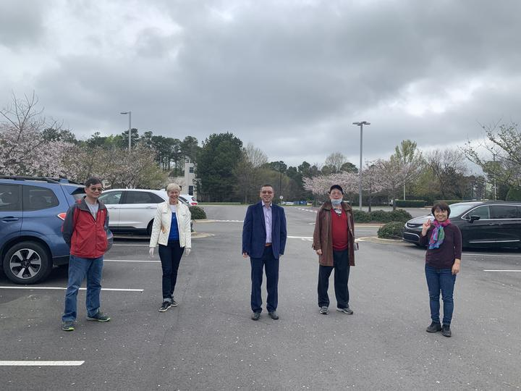

1. Collecting Donations
During the evening of March 22, CAFA called on its friends to donate their surplus supplies and received a good response. Apex resident Jie Chen delivered her masks to Kun Yang’s house.
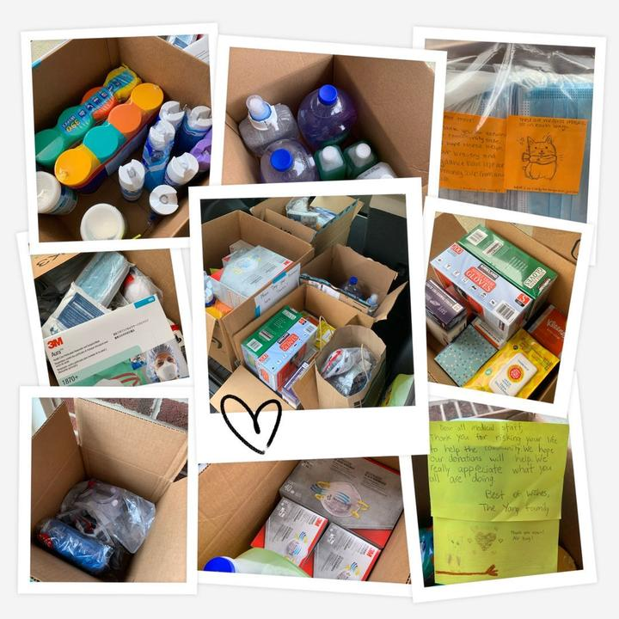
Donations from residents of Weldon Ridge
Residents of Weldon Ridge pulled through and donated half of the collected supplies. Weldon Ridge’s residents sent representatives to deliver donations in person. Jian Ma’s group had purchased 400 KN95 and 1,200 general masks for personal use. They only kept enough for themselves and entrusted the rest of the supplies to Jian Ma to donate.
Ying Yan and Tony Yao took initiative and helped pick up the donations. There is a wide range of donations, including masks of various brands, hand sanitizers of different sizes, disinfectant alcohol, shoe covers, and soap that are not on the list of urgently-needed medical supplies.

2. Delivering Supplies
In less than two days, a total of 1160 masks, 52 tubes of disinfectant paper towels/ sprays, 12 large bottles of hand sanitizer, 2,250 gloves, 2 sets of scarce Tyvek full-body protective clothing (courtesy of Jian Ma), and a number of alcohol soap shoe covers were collected.
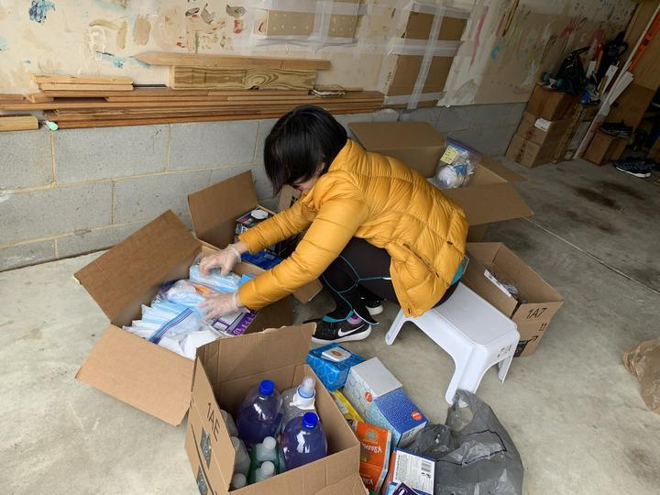
Ying Yan works hard to sort and pack supplies into different boxes
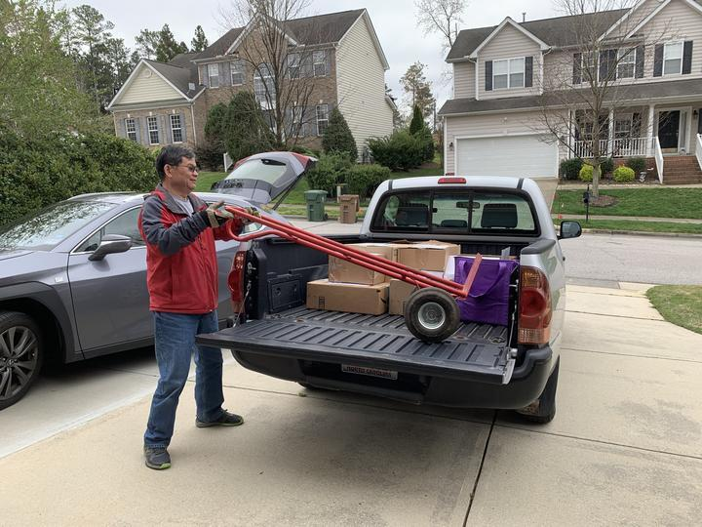
Xingliang Zhou stores donations his pickup truck
Yesterday afternoon (March 24), three volunteers—Ying Yan, Xingliang Zhou, and Kun Yang—joined Deborah Ross, who is running for US Congress, to deliver the donations to WakeMed Hospital in Cary.
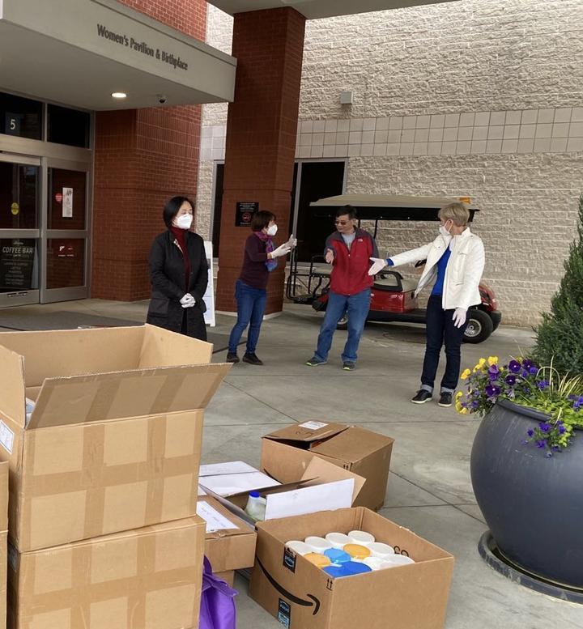
Deborah posing with volunteers
Coincidentally, the US-China Economic and Cultural Association (CAECA) just received a generous donation of 4,400 disposable medical masks and 600 KN95 masks from friends in China. CAECA decided to donate to the hospital, so they sent volunteers Haihui Huang and John Wei to join the delivery team.
Haihui Huang, chairman of the CAECA, says that the disposable medical masks were donated by Jian Lu, CAECA’s director in China, and iPearl paid for the shipping. The KN95 masks were purchased by Huang and donated on behalf of CAECA. This donation also reflects the sincere appreciation of the Chinese overseas for helping Wuhan fight COVID-19.
CAECA’s Founder, John Wei reveals that Haihui Huang has bought tens of thousands of masks from China that will soon be shipped to North Carolina. They will donate the masks to local medical staff.

3. Hospitals Receiving Supplies
WakeMed is very grateful for the donations. WakeMed Senior Vice President Mr. Thomas Gough and Government Affairs Manager Ms. Andi Curtis collected the donation delivery on behalf of the hospital. They expressed their thanks and commented that all types of masks are appreciated.
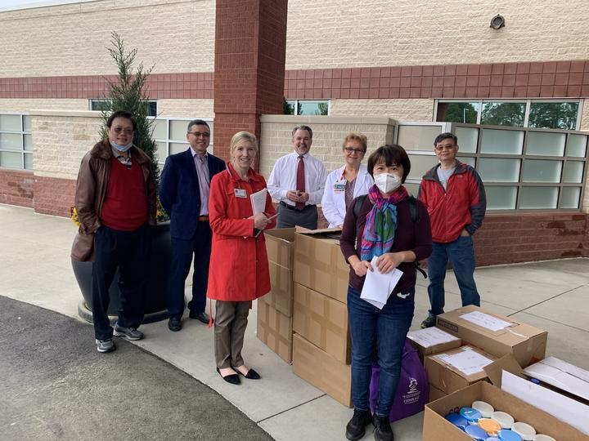
Hospital people and the delivery team taking a photo
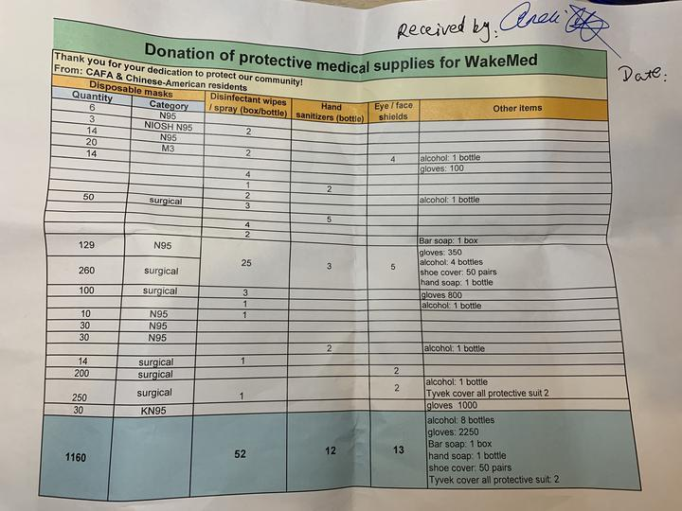
List of donations, signed by Andi Curtis
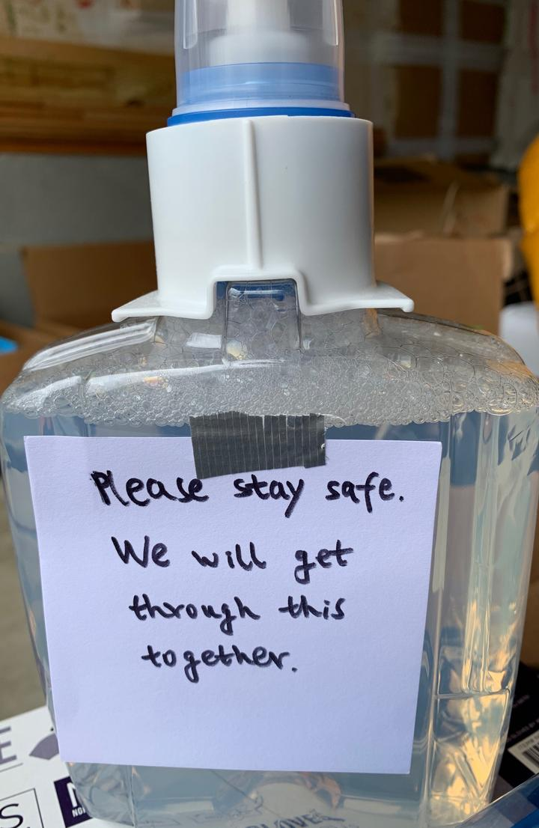
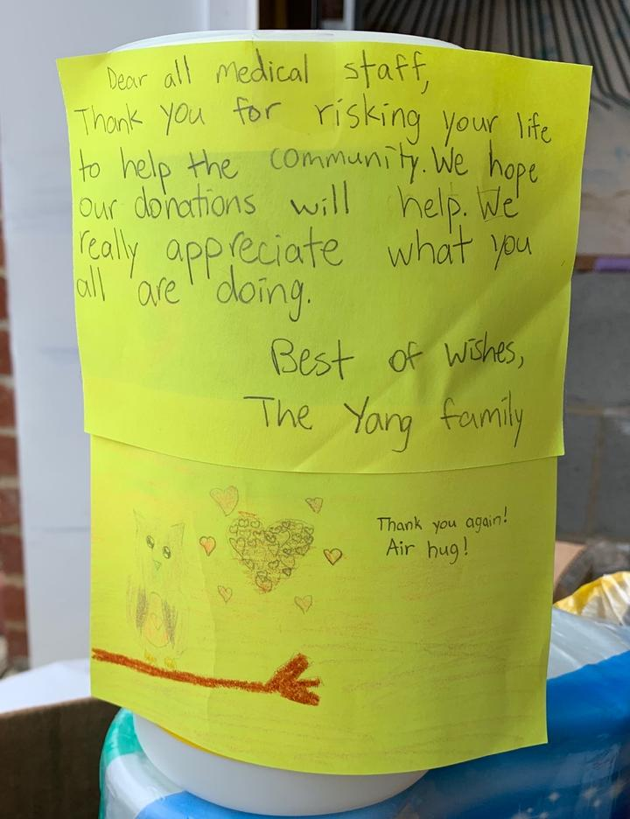
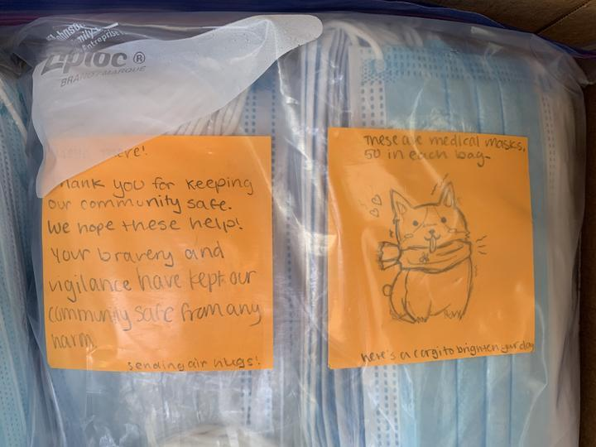
Messages left by those who donated materials

The fundraising initiated by CAFA is still ongoing, link: https://nccafa.org/donate-covid-19/

